Final Opportunity to get your Pancake Breakfast tickets and support our OP Students Safe Grad event
Ticket orders will be accepted until noon Monday March 4th

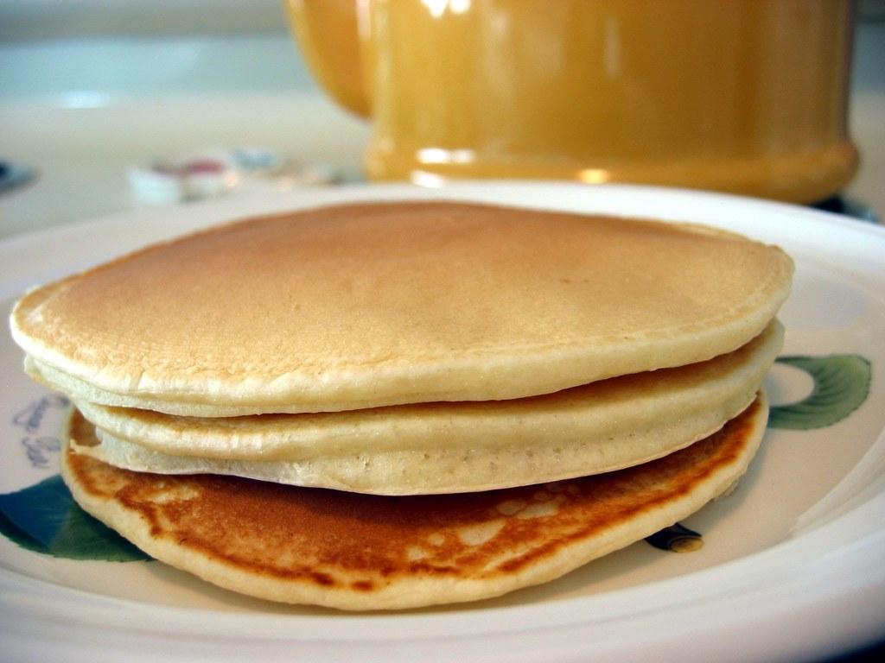
Sunday March 10th - Pancake Breakfast
Park West Inn at 525 Dale Boulevard
To order tickets email oakparksafegradfundraising@gmail.com

THANK YOU for your support in gathering and providing very generous Silent Auction prizes to be raffled at the Pancake Breakfast

As well parents, the attached sponsorship form “OP Vegas in the Peg” provides an opportunity for individual or business Sponsorship to support the fundraising efforts for the 2024 Safe Grad event. We cannot meet our fundraising goals without the amazing support and financial dedication from families, businesses and friends of our OP 2024 Grad Students. Please share this document in request of financial support for our Safe Grad.

Have a great weekend everyone.

SOCIAL MEDIA
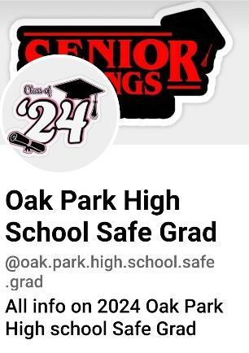
Please find and follow Oak Park High School Safe Grad at https://www.facebook.com/oak.park.high.school.safe.grad?mibextid=LQQJ4d

