WHYTE RIDGE SCHOOL PARENT ADVISORY COUNCIL
Meeting Minutes
7:00pm May 7, 2025
400 Scurfield Blvd
Co-Chairs: Sam Lewycky & Rav Kaler

Ashton du Plessis | Sam Lewycky | Rav Kaler
Megan Ball | Sarah Rasmussen | Sarah Neufeld
Kim McGregor | Jill Hinter | Heather Bosko
Steph Johnson | Yevhen Viznytsya | BJ Neufeld
School Team: Cyndi Tibbs, Ms. Myler, Ms. Walker

Secretary: Ashton du Plessis

Agenda Item | Lead
Approval of Agenda & Minutes from last meeting  Motion to approve April 2025 minutes  Moved by: Sarah Rasmussen  Second: Jill Hinter  Carried | Rav/Sam
Grade 4 Teacher Presentation  Grade 4 Update  - Animals – habitat  - Multiplication, division, fractions and decimals  - Provinces and Territories research  - Getting ready for Grade 4 farewell  - PLC on Word Study  - Walking to HGI  - Transition meetings have started for students leaving school | Ms. Myler, Ms. Walker
Co- Chair Report  - Spring Fundraiser  - Total of $9,350 was spent on the Lacoste Fundraiser, leaving us with a profit of $2,008.50  - Pickup was yesterday and went smoothly.  - We had made a decision to use the money spent and passed a motion to approve spending up to $1,700 to purchase magnetic letters and cookie sheets for 140 students in grades 1 and 2 to support classroom implementation of the UFLI program.  Motion: To use funds from our spring fundraiser to purchase supplies to support classroom implementation of the UFLI program for 140 students  - Money given to library for language books – sourced $220 worth of books in Chinese and Spanish, having trouble fulfilling the reminder. Ms. Munro asked if its okay to use the remaining amount on English language books.  Motion: Remaining money from PTSD to be used to purchase books for the school library.  Moved by: Sarah Rasmussen  Second: Jill Hinter  Carried  - Request Form for Teachers  - Had three requests that came through; discussed with PAC and made a motion to provide funds for two of the requests:  - 2 Grade one classrooms (1BM & 1HS) – watercolor crayons/paper for class book resembling the Indigenous book This is How we Know. Total cost was $271  - Patrica Meyler’s class for needle felting activity - $240  - Received one more request for t-shirts for the leaders at Dance in the Park, however the amount was over our budget so we replied and said we would still like to support this if they are able to find something cheaper.  - We able to find a cheaper option at $15 per t-shirt so asking for 20 t-shirts for leaders which would be $300  - For the next school year, in the early spring, we will take a look at our financial position and assess if we are able to provide some additional funding for classroom projects. If so, we will have Mike send out communication to the staff letting them know its available but may need to also say that there’s a budget of $150-$300 (could change depending on financial situation) per request. We will see review any request forms that come in throughout the year.  Motion: To spend up to $600 to purchase t-shirts for the Dance in the Park leaders. T-shirts will be kept at the school and reused each year.  Moved by: Ashton du Plessis  Second: Jill Hinter  Carried  - Outdoor space  - PAC members would like to continue to support the outdoor space but there are concerns/questions regarding what steps are taken if we can’t get to the desired amount of $25-30K  - $8,000 from PAC and some add’l amounts through a Grant that PAC would have to apply for ($3,500) and a small amount from the ISP program ($5,000).  - Fall Fundraiser – dedication to the outdoor space; treat it like a ‘pledge’ style allowing families/friends to make donations of their choice but have it tied to an activity for the students like a groove-a-thon  - School events in May/June  - We have two pizza lunches scheduled for May  - Kindergarten stay and play – info sheet/flyer in each take home bag  - Dance in the Park June 23 – PAC will provide freezies for this day – discussion will follow in email  - Planning for next year  - Communication to parents  - Possibly through teachers and having a ‘parent’ rep for each classroom  - September  - Community event – bbq again; PAC can have bouncy castles  - Discussion on our Fall Fundraiser | Rav/Sam
School Report
- Grade 1 students hosted Happiness assembly
- Next assembly to be hosted by Kindergarten and Grade 4
- Still many extracurricular activities
- Jump Rope for Heart – raised over $2000
- Fun Station Day June 12
- Grade 4 Farewell June 18
- Grade 4 transition to HGI
- Dance in the Park planning underway
- 584 students registered for next year
- Increase in office staffing for next year
- Increase in Music and Phys Ed time for 2025-2026 year
- Grade 4 Science Fair May 27
- Class placements and staggered entry messaging to come out at the end of June
- Soft Start plan for next year – more info to come
- June 13 PD Day
Financial

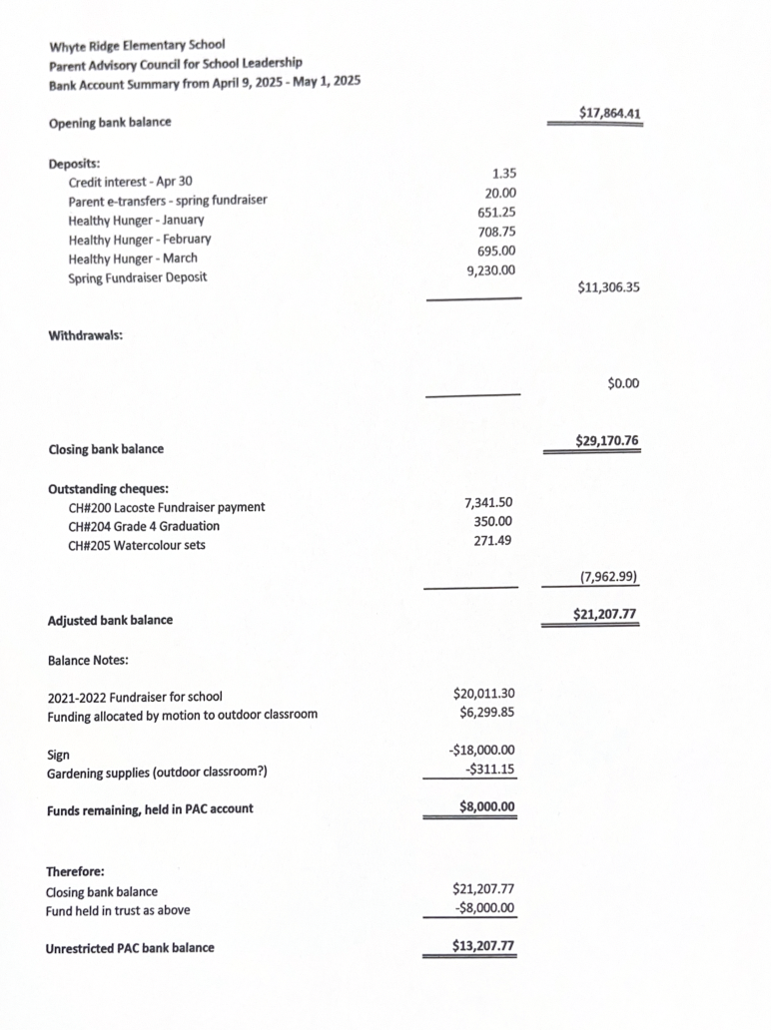

Program Reports  - Hot Lunch  - April 17 384 students $735  - May 8 354 $655  - May 22 and June 26 are last pizza lunch dates  - October – May Fun Lunch total funds raised $5252.25  - Option to add in a “donation” section to the hot lunch for October with plans to raise money for the Outdoor Classroom  - Sam to plan on taking over the Healthy Hunger | Megan
Financial Update | Sarah
In Camera Session | PAC Members

Next Meeting Date | Location
Wednesady , September 10 - 7:00pm | Library

