BAIRDMORE SCHOOL

KINDERGARTEN INFORMATION EVENING

THURSDAY, FEBRUARY 20th, 2025

6:00-7:00 P.M.

BAIRDMORE SCHOOL’S GYM

Bairdmore parents/guardians and their neighbours and friends are invited to our Kindergarten Information Evening on ***Thursday, February 20th, 2025, at 6:00-7:00 p.m. at*** ***Bairdmore School in the Gym***. This is an information evening for parents/guardians who live in the Bairdmore catchment who have children that were born in 2020 and will be 5 years old on or before December 31, 2025. This evening will provide information about our program and share information about our online registration process.

When registering your child *after* our Kindergarten Information Evening, you will need to scan or take a photo of your proof of address (i.e. mortgage, rental agreement, utility bill), your child's birth certificate or passport, and your Manitoba Health Card.

We look forward to meeting you at our ***Kindergarten Information Evening***, in person!

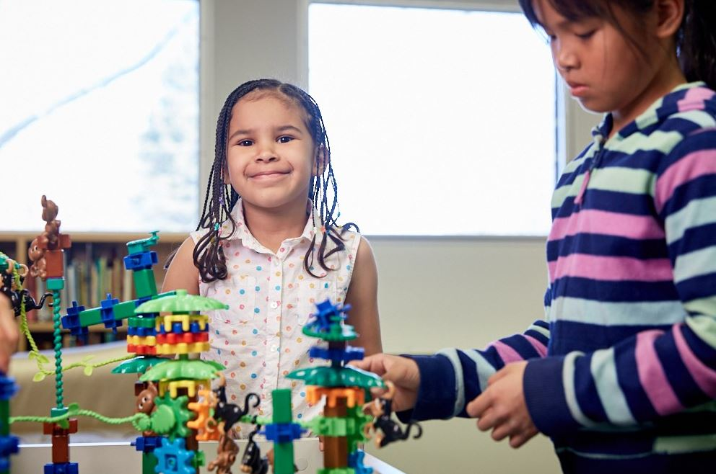

Please Note: We will be hosting a ***Welcome to Kindergarten*** evening which will take place in the spring for our future kindergarten students.