Administrator Report for February 2024 PAC Meeting

Mike Weekes and Cyndi Tibbs

Celebrations

- We had an assembly on January 24th to acknowledge bullying, peer pressure and citizenship. We welcomed in Blue Bomber great Adam Bighill and his team from Making Faces. We are super proud of how engaged and well behaved our students were.

- In January we continued to deal with recess incidents in a proactive way. This included conversations about solving problems by using “sand, pebble, rock” language. We continue to encourage our staff to communicate student issues with parents when necessary.

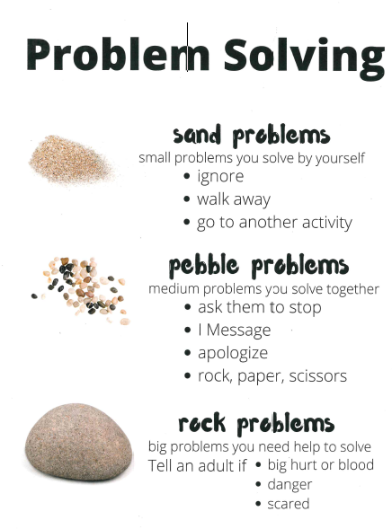
- When is it appropriate to walk away and find another friend to play with.
- What do sand problems look like and feel like and how to avoid escalating them to pebble or rock problems.
- Ownership for specific situations involving 2 or more people.
- How to seek out an adult (especially in situations involving the bus, recess or lunch).
- What language to use when giving and receiving an apology.

- In our grade level teams we are working on creating an awareness around diversity, equity and inclusion amongst students and staff. This includes conversations about what types of lessons are going on in classrooms to address issues with words spoken, opportunity for students and celebrating our diversity.

- We continue to run several extra-curricular programs – Run Club, Indoor Track, Intramurals, Student Action Club, Choir, Cribbage and Chess Club run in the mornings and at lunch.

- Our Kindergarten Open House was held on Thursday, January 30th and it was once again a huge success. Sixty-five families attended and our staff were super helpful and available, as we provided lots of information for new (and some old) school aged parents.

Office, Community and Staffing Updates

- Over the past year we have transitioned to using Edsby as our main communication tool for parent teacher conferences, attendance and reporting. More recently we used Edsby for report cards and this appeared to be a success. Parents who are having a hard time accessing Edsby are asked to contact our office (204-488-4245).

- Bussing, drop off and pick up is running smooth, and we ask that parents pay attention to the MyRide App for things like bus cancellations and other transportation announcements. Please remember that when busses are cancelled, this also means that students need to be picked up at the end of the day. More information on this and on next year’s bus registration can be found on the transportation website.

- Whyte Ridge continues to be a busy place with several new registrations. We are currently sitting at 613 students! In February students will receive student verification forms to bring home to parents, to confirm next year's enrollment. These forms were sent home on Wednesday, February 5th.

- A reminder to parents to make sure that your child has warm clothes for recess. All students go outside for recess (15 minutes in the am and pm and 30 minutes during the second half of lunch). Indoor recess happens when it is -27 (with the windchill).

- We would like to welcome Christina Cooper to our staff for the rest of the school year. Ms.Cooper is taking over 1TG for Mrs. Gross who is away on leave. Katie Shiach is back from her maternity leave, and we thank Ms. Brittany Braun for her time in 2BB this year. Welcome back Ms. Shiach.

Initiatives and Staff professional development

- On Friday, January 31st we had our first teacher professional development of the year. The focus was on classroom literacy plans/practice, diversity, equity and inclusion.

- Our student services team continues to balance supporting classroom teachers with student interventions, one on one intensive support, and additional resource, with student and classroom regulation.

- We continue to work with PAC on improving our outdoor space.

February is I Love to Read and Festival

We will have Festival du Voyageur week February 10 -14. Each morning, Mrs. Krietz will say the French word of the day during announcements.

- There will be pictures of the item posted in the main hallway.
- Students are encouraged to count and name the items in French.
- Thursday, February 13th will be Dress Like a Voyageur Day when staff and students are invited to wear a toque, boots, a plaid shirt, a sash and anything else in the voyageur spirit.
- Optional activities will be made available all week long like snowshoeing, snow sculpture building, bracelet making and learning a voyageur song.
- Teachers will also include lessons on the history of the fur trade and the importance of French, Indigenous, and Metis contributions and culture of that era.

This month is “I Love to Read Month” with the following activities:
School Plan
Visionary - hopeful
Purposeful – clear and doable
Inclusive – student centred
Aligned – division aligned
Practical – patient but impactful
Responsive – what we know and see

Two Areas of Focus

Literacy – Robust/all encompassing

- Showing growth in targeted areas
- Collaboration to foster resiliency
- Structures (teams, timetables)
- Classroom instruction
- Teacher toolkits
- Student services/supports

Engagement through a lens of equity, inclusion and anti-racism

- EAL, newcomer, CFS, ISST
- Cultural proficiency
- Community and citizenship
- Indigenous student supports
- Common understandings
- Circle of care

How will we know?
- Attendance
- Compass
- Data wall
- Faces on the data
- Class profiles
- Report Cards

  - Classroom reading challenges and special guests.
  - at our February 27th assembly.
  - Dress Up Week from February 10th-14th.

Monday, February 10th – Wear School Colours/Gear Day
Tuesday, February 11th – Dress Like a Character from a book
Wednesday, February 12th – Wear a Word Wednesday
Thursday, February 13th – Dress Like a Voyageur Day
Friday, February 14th – Fireside Friday (wear something cozy)

Tri-Conferences

- Thursday March 6th and will run in 30 minute intervals (3 families at a time). Tri-conferences will be a celebration of learning as teachers will be sharing evidence of student learning, that will also be reflected on report cards.
- We used the Edsby scheduling system with parents again, and we hope that this has been easy to use for parents.

Important Dates: February & March:
- Monday, February 17th - Louis Riel Day
- Thursday, February 20th – PAC Hot Lunch
- Thursday, March 6th - Parent Teacher Tri Conferences
- Friday, March 14th - School Admin Day
- Friday, March 21st - Report Cards Go Online
- Saturday, March 29th - Spring Break Begins

