**Busing and Walking School Bus Information**

Grade 6 General Byng students who currently live outside the 1.6 km radius to General Byng are eligible for busing. In order to receive busing you must register using the Pembina Trails online registration system. [Transportation (pembinatrails.ca)](https://www.pembinatrails.ca/page/556/transportation).

Pembina Trails School Division uses the Transportation App, MyRide K-12. This is the primary communication tool for busing families and the Transportation Department. Please click [here](https://media.pembinatrails.ca/media/Default/medialib/my-ride-form.7afe1b41891.pdf) for the instructions on downloading MyRide K-12.

**Walking School Bus Start Date – Monday, September 8th**

General Byng School provides two separate routes for the Walking School Bus (WSB) for students attending General Byng School in the 2025/2026 school year. The WSB is staffed by WSB Chaperones. These chaperones meet students at designated Muster Points each morning and lead the children on their walk to General Byng School. The chaperones meet students again at the end of the school day to lead the walk back to each Muster Point.

Students living in the Maybank, Beaumont, Cresent Park, or Wildwood areas may wish to access the WSB for their area. Please see below for specific Muster Point locations.

|  |  |
| --- | --- |
| **Walking School Bus Muster Point** | **Areas Supported by WSB** |
| **1325 Beaumont St** | Beaumont |
| **830 North Drive** | Wildwood, Oakenwald, Windermere |

**Beaumont Route** **Oakenwald Route**

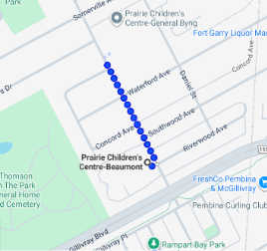                          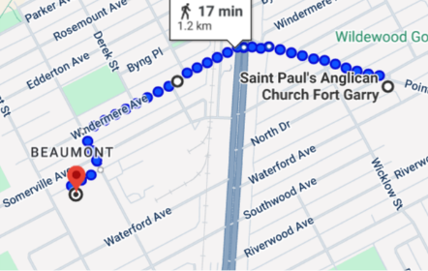

**Muster Point Schedule: Morning**

|  |  |
| --- | --- |
| **Route** | **Morning Walk from Muster Points to General Byng School** |
| Beaumont | **Muster Point:**  **1325 Beaumont (Prairie Children’s Center)**  **8 :50am:** Students living in the Beaumont area will meet out front of the Prairie Children’s Center.  **8:55am:** WSB departs for General Byng. |
| North Drive and The Point | **Muster Point 1:**  **830 North Dr. (Parking lot of St. Paul’s Anglican Church)**  **8:45 am:** Students will meet in the parking lot of St. Paul’s Anglican Church. Walk down Point Rd. and crosses Pembina Hwy.  **Muster Point 2**:  **Windermere and Pembina (back lane of The Point Apartment)**  **8:55 am:** WSB departs and makes its way down Windermere Ave. and then heads to General Byng. |

**Muster Point Schedule: Afternoon**

|  |  |
| --- | --- |
| **Route** | **Afternoon Walk from General Byng School Muster Points** |
| Beaumont | **4:00pm:** WSB leaves General Byng School.  **Muster Point 1:**  **1325 Beaumont (Prairie Children’s Center)**  **4:05pm:** Students arrive at Prairie Children’s Center to be dropped off |
| North Drive and The Point | **4:00pm:** WSB leaves General Byng School.  **Muster Point 1:**  **Windermere and Pembina (back lane of The Point Apartment) at 4:10 pm**  WSB leaves to cross Pembina and walk down Point Rd.  **Muster Point 2:**  **830 North Dr. (Parking lot of St. Paul’s Anglican Church) at 4:20 pm** |

**The Walking School Bus program is a school initiative, and all students are expected to demonstrate General Byng School’s Values: *Kindness, Respect and Responsibility****.* Parent/guardians will be notified when their child is not following Walking School Bus expectations. If unexpected/unsafe behaviour continues, parents will be notified that their child can no longer participate in the Walking School Bus.

Walking School Bus students are supervised by Walking School Bus chaperones. The chaperones will be wearing bright yellow and orange vests. The Walking School Bus will walk to and from school as a group, with adult walkers leading and supervising the group.**It is the responsibility of the parent/guardian to bring their child to the Muster Point meeting place and pick them up at the same Muster Point at the end of the school da**y **at the designated times.** **The Walking School Bus does not provide a door-to-door pick up/drop off service for families.**

If you are interested in having your child(ren) participate in the General Byng Walking School Bus program, please complete, and sign the Walking School Bus Permission form <https://permission.click/XjWjX/ca> Please complete the permission form by Thursday, September 4th.Once permission is received, your child will be enrolled in the Walking School Bus program.

Sincerely,

Tracey Groening Sarah Hampton

Principal Vice-Principal