August 28, 2026

Hello General Byng Families,

We are in full swing putting the finishing touches on the school and preparing for the year ahead and we couldn’t be more excited!

The following pages provide an overview of important information including:
- Important Dates
- School Fees / Lunch Fees
- Year-long Permission Forms (Walking Field Trips and Smudging)
- Morning Procedures / Student Drop-Off and Pick-Up / Walking Student Bus / Eligible Grade 6 Bussing
- Supplies
- Additional Procedures

The following permission/registration and payment links are in this document:
- School Fees – payment form (if you are paying online, or paying cash/cheque, you must complete this form every time you make an installment payment and then send the cash/cheque to the school)
- Lunch Program Registration and Fees - (if you are paying online, or paying cash/cheque, you must complete this form and then send the cash/cheque to the school)
- Walking Field Trip Year-long Permission
- Smudging Consent
- Walking School Bus – see information below to see if you are eligible.

Please send all grade 1-8 students to school on Wednesday, September 9th. Kindergarten students have been contacted by Ms. Reena Pal for their assigned staggered entry information. If you have not received your Welcome to Kindergarten package, please contact the main office.

We are looking forward to welcoming our students back to school on September 9th! Thank you for your time and attention to reading this information. Please do not hesitate to contact us with feedback, questions or concerns.

Sincerely,

Tracey Groening Lindsay Stewart
Principal Vice-Principal

OVERVIEW OF INFORMATION

Important Dates:

September 7 Labour Day NO SCHOOL
September 8 Metro Common Day NO CLASSES
September 9 Grade 1-8 First Day of Classes
September 9 Kindergarten assigned 15-minute individual meetings
September 10 or 11 Kindergarten Staggered Entry
September 17 Meet the Staff Event 5:00-6:00 p.m.
September 24 Strong Beginnings NO CLASSES – except by appointment
September 25 Strong Beginnings NO CLASSES – except by appointment
September 30 National Day of Truth & Reconciliation NO SCHOOL
October 2 Grade 6 Immunizations
October 12 Thanksgiving Day NO SCHOOL
October 14 Picture Day
October 15 Tri-Conferences 4:30-7:00 p.m.
October 20 Tri-Conferences 4:30-7:00 p.m.
October 23 Metro Common Day: MTS PD NO CLASSES
October 28 Divisional Common Day NO CLASSES
November 5 Grade 6 Immunizations
November 11 Remembrance Day NO CLASSES
December 2 Kindergarten – Grade 5 Winter Concert 6:00 p.m.
December 4 Admin Day NO CLASSES
Dec. 21 – Jan. 1 Winter Break NO SCHOOL
January 29 Divisional Common Day NO CLASSES
February 2 Mobile Vision Clinic
February 5 Metro Common Day NO CLASSES
February 15 Louis Riel Day NO SCHOOL
March 19 Metro Common Day NO CLASSES
March 23 Class Picture Day
March 26 Good Friday NO SCHOOL
March 29 – April 2 Spring Break NO SCHOOL
April 14 Celebration of Learning 4:30-6:00 p.m.
April 14 Middle Years Open House 6:00-7:00 p.m.
April 16 Metro Common Day NO CLASSES
May 24 Victoria Day NO SCHOOL
June 11 Divisional Common Day NO CLASSES
June 29 Last Day of Classes
June 30 Admin Day NO CLASSES

School and Student Fees
Collection of school fees will take place via this Permission Click link: School Fees payment.
Fieldtrips will be paid for as they arise via Permission Click. Please read the following handout overview: General Byng School Supplies

Student Fee $35.00 (for grades K-8)
Covers the cost of lock, agenda book, and supplies.

Program Fee $15.00 (for grades 6-8)
Covers additional costs in Art, Band, and Technical Education courses.
*Band instrument rentals are an additional cost.

Total School Fees by Grade:
Grades K-5 $35.00
Grades 6-8 $50.00
DUE BY: September 15, 2026 School Fees payment

Nutrition Break / Lunch Program

Nutrition Break:
- Grades K-5 Nutrition Break will occur directly before or after the morning recess. Please send a healthy snack for this break.
- Grade 6-8 students are encouraged to have a healthy snack during locker break at 10:45. Please send a healthy snack for this break.
- Our nutrition program also offers snacks to students.

Lunch Program:
- To stay at the school for the lunch hour, students must be enrolled and have paid for our lunch program. The fees allow us to hire outside staff to supervise students as school teaching staff, by contract, have a duty-free lunch hour.

- Lunch Program registration and fees will take place via Permission Click:

Lunch Program Registration and Payment

*NEW: this year the division has standardized lunch fees across the division to $150.00 per student for the year. The Permission Click Registration and Payment link gives you multiple options for payments (full/partial/instalments).

- Students not registered for General Byng’s Lunch Program must be off school grounds from 12:15-1:15.

General Lunch Hour Information:
- The sharing of food/snacks is prohibited.
- General Byng is a peanut and nut aware school. Please attempt to provide lunches and snacks that are nut-free.

Reminder: Students not registered for General Byng’s Lunch Program must be off school grounds from 12:15-1:15.

Walking Field Trips – Year-long Permission
Given the impromptu nature of walking field trips, General Byng is seeking, in advance, informed consent for your child to participate. Rather than sending home a separate permission form for each walking field trip, please complete the linked consent form which will cover your child’s walking field trips for the entire school year.
Year-Long Permission Form Walking Field Trip

Smudging
Smudging is a tradition, common to many First Nations, which involves the burning of one or more medicines gathered from the earth. The four sacred medicines used in First Nations’ ceremonies are tobacco, sage, cedar, and sweetgrass. The most common medicines used in a smudge are sweetgrass, sage, and cedar. Smudging has been passed down from generation to generation. Smudging allows people to stop, slow down, and become mindful and centered. This allows people to remember, connect, and be grounded in the event, task, or purpose at hand. Smudging also allows people to let go of negative feelings and thoughts. Letting go of things that inhibit a person from being balanced and focused comes from the feeling of being calm and safe while smudging.
The Pembina Trails School Division has developed procedures which will be followed for smudging with staff and students in schools. Participation in smudging is always voluntary and requires parent/guardian permission. Smudging is done in a designated area(s) at the school and any school sanctioned events.
Students must have signed consent to participate in smudging at school. By signing the Permission Click form below, students will have permission to participate in smudging in a designated area of the school and any school sanctioned events.
Smudging Permission Form

Building Access, Entrance and Exit Information
- All school doors will be locked during the day.
- Visitors must enter through the front door. Please ring the doorbell located on the wall to the right of the main doors to be granted access.
- Before and After School: Please drop off your child between 9:00 and 9:10 AM to ensure your child is in their class for 9:20 AM. Dismissal pick-up is 3:55 PM daily. There is no before or after school supervision.
- Students can enter the school at the 9:10 AM bell and should enter through the following doors:
  - Daycare Entrance (back doors by the parking lot): Kindergarten – Gr. 3
  - Garden Doors (by the play structure): Grade 4 – 6
  - Front Doors (main door off Beaumont Street): Grade 7 and 8
- Parents and guardians must wait outside when dropping off or picking up their child.
If you are driving your child/ren to school, we ask that you follow our procedures:

Please use Daniel Street and NOT Beaumont Street. Beaumont is extremely busy and hosts both Winnipeg Transit and Divisional buses. We want to be courteous of our neighbours.

- Please travel south on Daniel Street to drop off your child/ren.
- Please do not park in the STOP, DROP and GO! drop zone on Daniel Street south of the back lane. We ask that you leave 3 car lengths for cars to pull in, drop their child/ren off safely, and resume driving south on Daniel Street.
- We must remain mindful that Daniel Street is used by the entire community therefore please do not stop on the north bound side of Daniel Street. The north bound side of Daniel Street is a “no stopping zone” and is extremely dangerous and will become increasingly dangerous as the winter weather rolls in.
- Please have your child exit the curb side (passenger side) back door where our staff/student Welcome Team will welcome them and assist your child in exiting the vehicle by closing the door behind them.
- Pull back out onto south bound Daniel Street and enjoy your day!

NOTE:
- Only General Byng staff, Prairie Children’s Daycare staff and families will be granted access to the back lane between the hours of 8:30 AM and 9:30 AM.
- The back lane is one-way traffic between the hours of 8:30 AM to 9:30 AM and 3:30 PM to 4:30 PM. *There is a City of Winnipeg traffic sign at the entrance off Beaumont Street stating there is no entry off Beaumont Street.
- General access to the back lane is only available between 9:30 AM and 3:30 PM.
- DO NOT park in the back lane at the end of the day to pick up your child. Use Daniel Street to park. It is unsafe to have children crossing the back lane to enter vehicles.
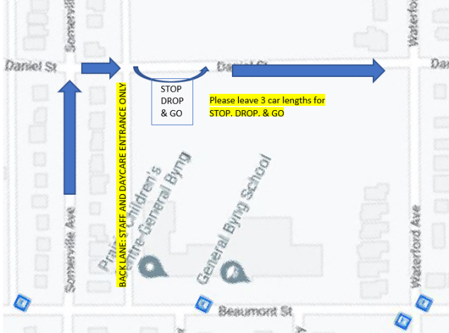

- Walking and Biking: We have the good fortune for our families to live in this accessible community. We encourage families to walk or bike to and from school. Please ensure bikes are locked up on the bike rack. Let the office staff know if you need to borrow a lock or tire pump. We recommend a strong U-LOCK for your bicycle.
- If you would like to enroll your Grade 1-6 child in our WALKING School Bus. Staff members will meet students at a designated location and time and escort them to school in the morning and then return with them to the same location after school.
Please use the following link to register your child. Registration closes on September 11th at midnight. If you would like to register your child after September 11th, please contact the school main office. If you would like more information, please click the link below.

DETAILED INFORMATION: Walking School Bus Information
WALKING School Bus Registration: Registration for Walking School Bus
Eligible Grade 6 School Bus Information
Please note that General Byng School is not involved in the transportation registration process or in determining transportation eligibility.
Pembina Trails Transportation Department will communicate directly with families. Finalized bus route schedules should be sent by the division before the end of the day, Friday, September 4.
- Please visit the division’s transportation website for more information: Transportation (pembinatrails.ca)
- Please download their Transportation App, MyRide K-12. This is the primary communication tool for busing families and the Transportation Department. Please click here for the instructions on downloading MyRide K-12.

Absences and Late Arrivals
- If a student is away from school, please use Edsby to submit their absence. Or call the school office (204-452-3040). If you are unable to use Edsby, please email gbattendance@pembinatrails.ca.
- If a student is late for school (arriving after 9:20 AM or in the afternoon after 1:20 PM), the student must enter through the main school doors to access the building. Please ring the doorbell as the school doors will be locked. *Do not use the doorbell at the parking lot door – this is for the daycare, not the school.

School Supplies, Lockers and Cubbies
- School supplies have been purchased and will be given to students in Kindergarten through Grade 8 during the first week of classes.

Please send the following items with your child:
- a backpack for materials from home
- a labelled water bottle
- all items listed in the supply list: 26/27 Supply List
If your family would like assistance accessing any of these items, please contact the school office.

Pembina Trails Guidelines on Cell Phones and Personal Mobile Devices (PMDs)

Cell Phones and Personal Mobile Devices (PMDs) are not permitted during school hours in Manitoba Kindergarten - Grade 8 schools.

Please review the Pembina Trails Guidelines on Personal Mobile Devices (PMDs)

Personal Mobile Devices may include, but are not limited to, any piece of lightweight electronically powered equipment. These devices are typically consumer electronic devices capable of communications, data processing and/or utility. Examples range from hand-held lightweight electronic devices such as tablets, e-readers and smart phones to small devices such as MP3 players, smart watches and electronic toys.”

At General Byng School, these items should be kept in your locker if brought to school.
If a student is found to have their phone or device on them at school, they will be asked to put it in their locker. The second offense will result in the staff member taking the device and returning it to the student at the end of the period or school day and contacting home. If there is a third offense, the device is brought to the office, and returned to the student at the end of the school day; administration will contact home. If there is another offence the device will be brought to the office and a parent must pick up the device.

Parent / School Communication
- Please communicate with your child’s classroom teacher, administration, or the school office through Edsby, phone or email. Instructions to set up Edsby
- If you need to meet in person, please contact the main office to make an appointment.
- School updates, news, and information will be emailed via School Messenger and posted on our school website under: Community / General Byng Community Updates

Year-at-a-Glance 2026-2027
We have also attached the overview of the 26-27 calendar so you can begin to plan accordingly. Please note that Strong Beginnings (September 24 and 25) are not regular school days. Each child will be required to schedule an individual appointment time with their homeroom teacher. Information on how to schedule your appointment will be sent in the coming weeks. Students will only attend school on these two days during their mandatory 1-hour appointment time.

DAILY SCHEDULE
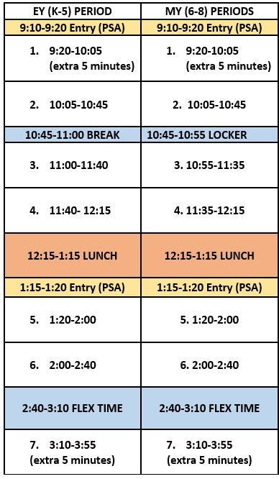
Lunch Hour Breakdown:
Students will have 30 minutes to eat lunch and 30 minutes outdoors.

Students MUST be enrolled and fees paid to stay on school grounds for lunch hour.
Grade 1-6 students must remain on property during lunch hour.
Grade 7 and 8 students enrolled and wanting to leave school grounds on a particular day must have permission granted by guardian when they enroll in the program (see Lunch Program Registration and Fees).

**Exception: students who are signed up for lunch hour clubs, may stay for the club even if they are NOT enrolled in the program.
TEACHING STAFF
Below is a list of our 26-27 teaching staff:

Homeroom Teachers:

Kindergarten: Ms Reena Pal
1/2E: Ms Julia Emmons
1/2P: Mr. Rich Palka
3/4W: Mr. Kent Whiteside
4/5K: Mrs. Gurpreet Kaur
4/5KL: Ms Kristin Klyne
6B: Mr. Faheem Bokhari
6M: Mr. Reid McGregor
6R: Mr. Derek Riediger
6V: Ms Melissa Vickar
7B : Ms Sunshine Bruderer
7K: Mr. Bruce Kemp
7M: Ms. Phoenix Murphy
7P: Mr. Ryan Parnell
7R: Mr. Josh Robertson
8B: Ms Lindsy Baudry
8K: Mrs. Sarah Karam
8R: Mr. Matt Reimer
8T: Ms Sarah Taleb

Specialists:

Phys. Ed. Ms Evelina Pescitelli
Mr. Thomas Watt
French Mme. Costales
French/Art Mr. Rezai
Music/Band Mr. Byron Lebois
Art Ms Marilee Van Nice
Libarian Ms Amy Coulling

Support Staff:

Resource
Grade K-5 Ms Ali Strome
Grade 6-7 Ms Jen Karpenko
Grade 7-8 Ms Riley Carmichael

Guidance
Grade K-8 Mr. Daniel Camaclang

English as an Additional Language
EAL K-8 Ms Ainsley Scibak

