We are so excited to share our next fundraiser with you!
Our online 50/50 raffle is LIVE!
Through Funding Change, an organization that supports groups like our Safe Grad Committee, we will operate the online 50/50 raffle until May 31/24. This is a progressive 50/50 raffle with the winner receiving half of all proceeds! Details and rules are listed on our Funding Change page, but please note you must be a resident of Manitoba, or physically in Manitoba to purchase tickets.
Click on the Lottery link https://www.fundingchange.ca/oakparkgrad/Za6iSNkEJliIqBLA?ref=Za6g_MVLz3s7hmoV to buy tickets and read the rules - it is that easy! Please hit the share button after your purchase and let family, friends, co-workers and others have an opportunity to support our Grads and win some cash!
Thank you for your continued support of our OP 2024 Grads and our fundraising efforts.
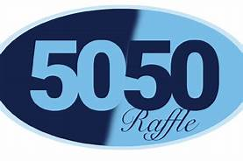

SOCIAL MEDIA
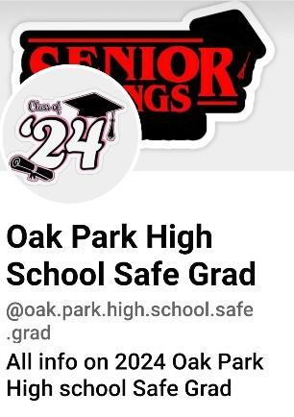
https://www.facebook.com/oak.park.high.school.safe.grad?mibextid=LQQJ4d

