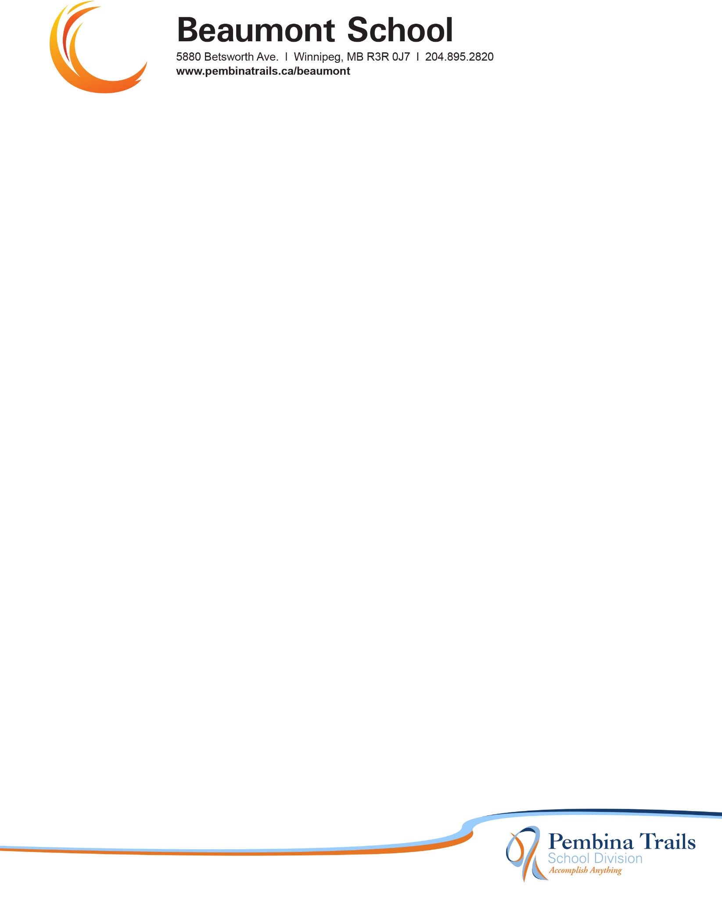

Dear Families of Grade 2/3 Black,


Beaumont School will purchase school supplies in bulk for students in Kindergarten through Grade 5 for the 2026-2027 school year.

The total owing for your child’s Student Fees is $50.00. This money is used to cover the cost of student supplies to be used in the classroom.

Permission Click is one of the options to pay for student fees. A link will be sent out in late August with details on how to use this online payment option. A cheque for $50.00 may also be sent and made payable to Beaumont School, or cash is also accepted. This may be sent to the classroom teacher on the first day of classes. If fee payment presents a challenge for your family, please reach out to Mrs. Hanna to discuss possible payment options.

Students are asked to bring the following to Meet the Teacher on Tuesday, September 8 to or the first day of school Wednesday, September 9:

- Backpack (large enough to hold items the size of a file folder)
- 1 pair indoor running shoes for Phys. Ed. class (No skateboard shoes, crocs, or shoes with zippers or elastic laces as they do not provide the necessary firm support for Phys. Ed. class)
- One refillable water bottle
- 1 box of Kleenex
- 1 box large Ziploc bags
- 1 set of headphones

The school office will re-open on Monday, August 31 at 9:00 a.m.

We are looking forward to welcoming our students back to school on Wednesday, Sept. 9 at 8:50 a.m.

