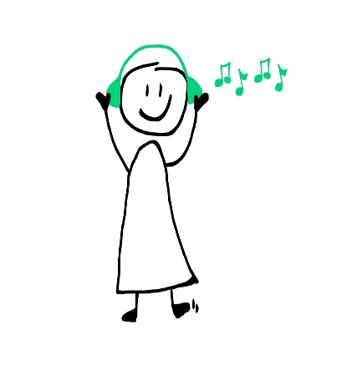
Kindergarten music building blocks include whole-body movement, whole-body listening, speech, singing, stories, exploring sound with feelings, pattern reading and writing. Children benefit from listening to and experiencing a variety of Musics as they develop speech and language skills in preschool years.
The list below includes resources for quality listening opportunities. You will find an assortment of styles for sing-a-long, dancing, moving together with mom or dad, plus crafting or quiet time.
If you enjoy listening to classical music together with your child, one simple activity is to engage the imagination and make-up a story to go along with the music. Try to act it out, or use a large sheet of paper and draw a picture of the story together. Let your little one create and imagine!

Have fun exploring, listening, and creating your own favorites playlist. Go into Spotify and search this title; Whyte Ridge Kindergarten Family Playlist. The playlist includes these artists should you want to search for them elsewhere.

Jim Gill
Sharon, Lois & Bram
Best of Raffie
Elizabeth Mitchell
Ella Jenkins
Kathy Reid-Naiman
Charlie Hope
Okee Dokee Brothers
Dan Zanes
BNL – Snacktime!
Music Together
Bounce Patrol – Wecome To The Farm
Charlotte Diamond

